**Report “Exit Task”**

**Anton Tserakhau**

# Result Task 01: Test Star Data

I have created required objects.

## SCD2 Dimension

I have two SCD2 Dimensions: DIM_DISHES_SCD and DIM_GEO_LOCATIONS.

DIM_DISHES_SCD:

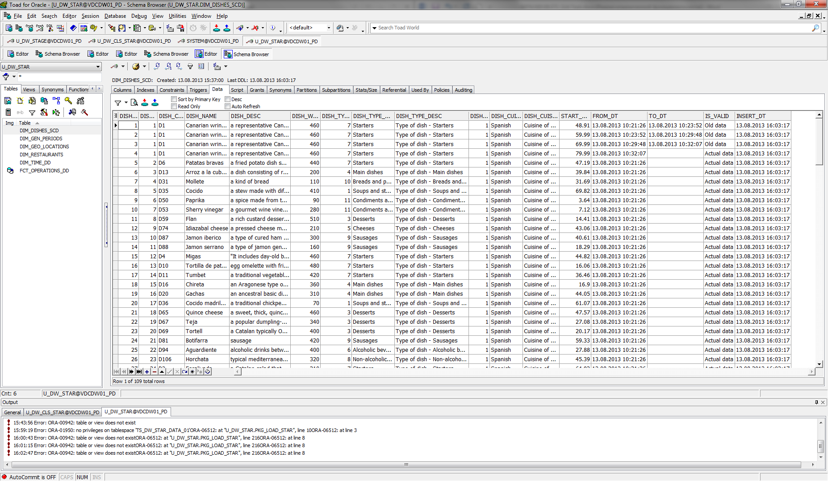

DIM_GEO_LOCATIONS:

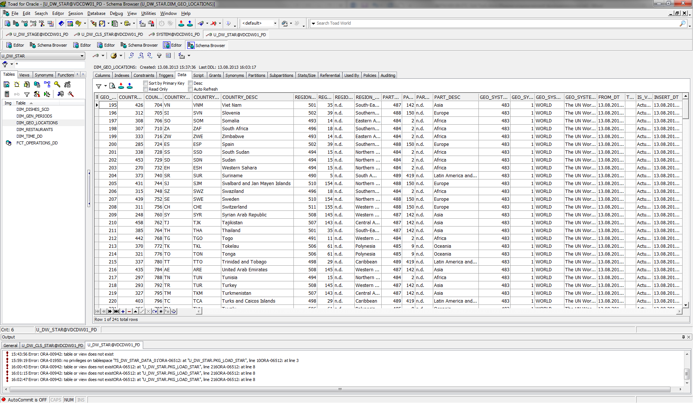

## Common Dimension

I have three Common Dimensions: DIM_GEN_PERIODS, DIM_RESTAURANTS and DIM_TIME_DD.

DIM_GEN_PERIODS:

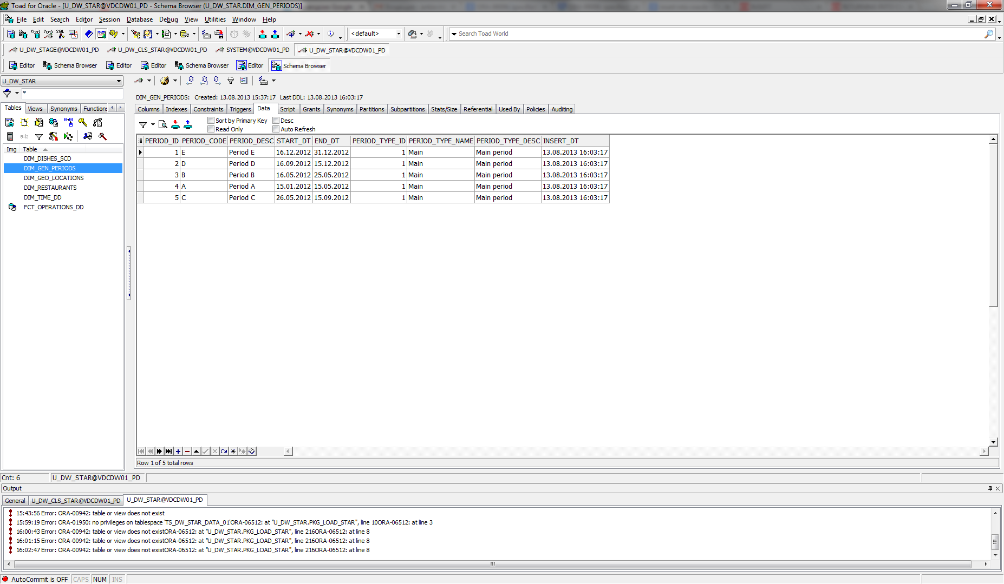

DIM_RESTAURANTS:

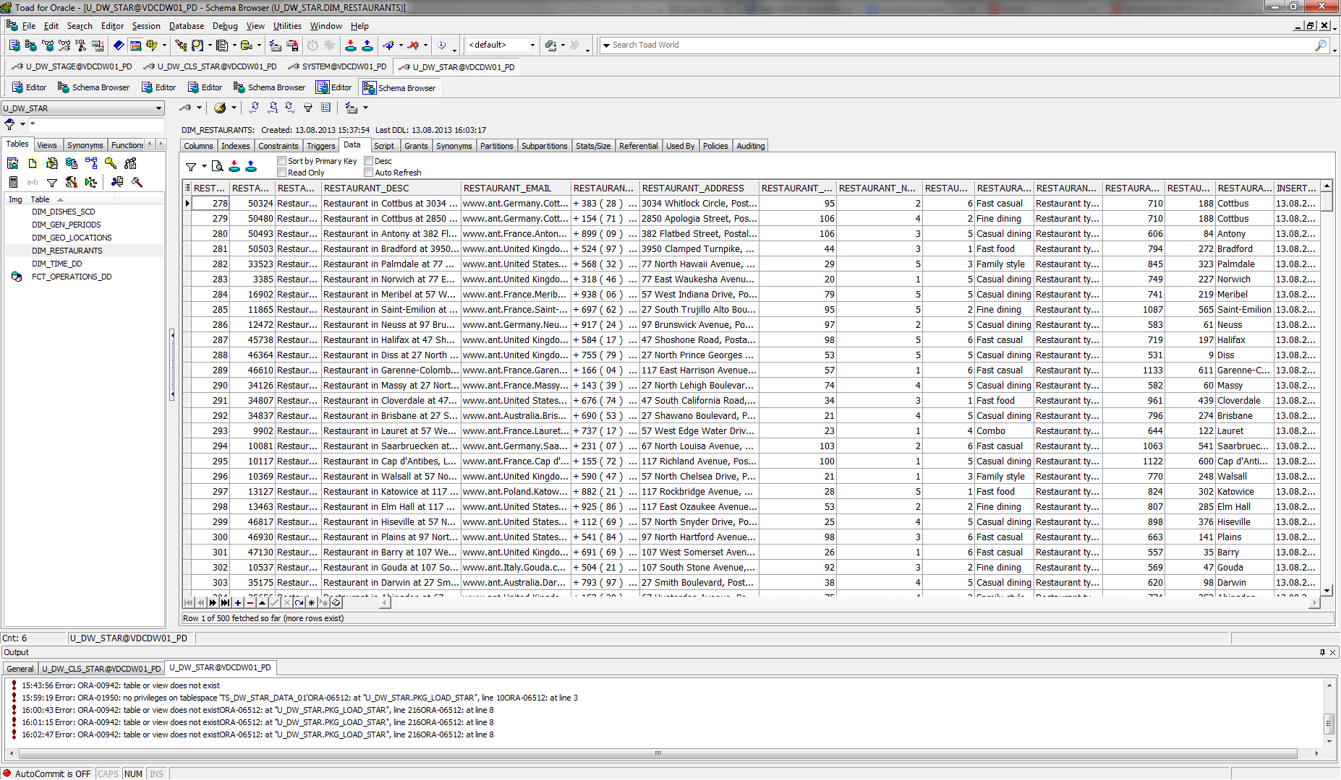

DIM_TIME_DD:

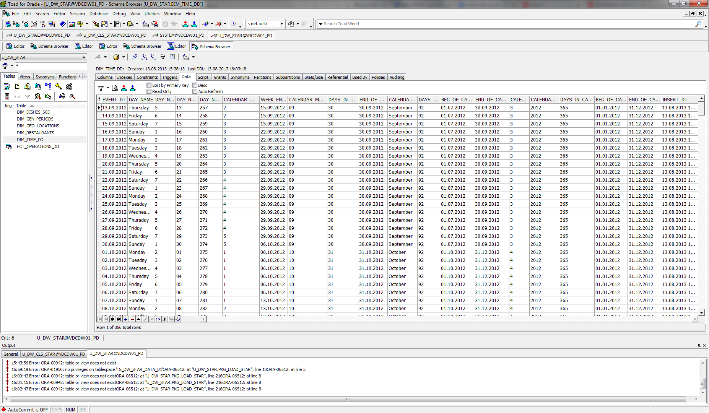

## Fact Table

I have Fact Table FCT_OPERATIONS_DD:

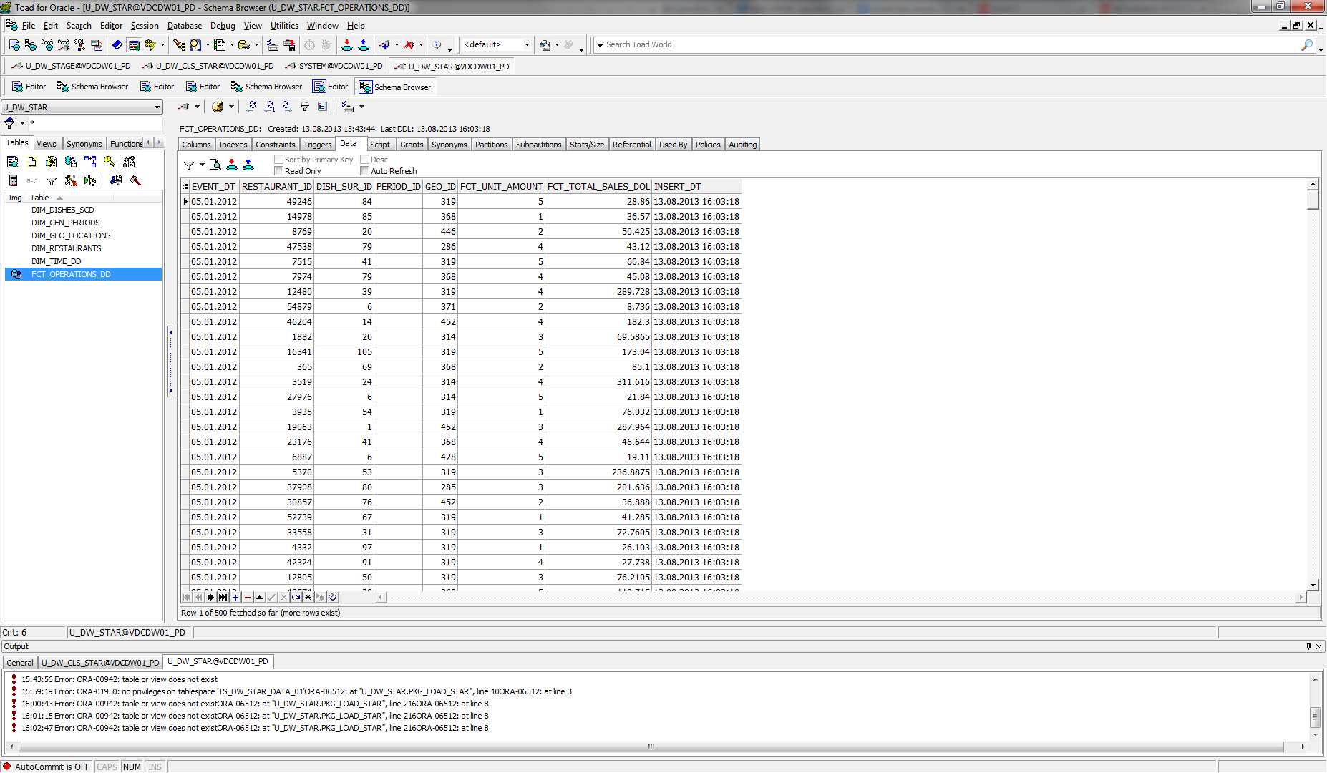

## Source Solution Scheme (Physical Objects)

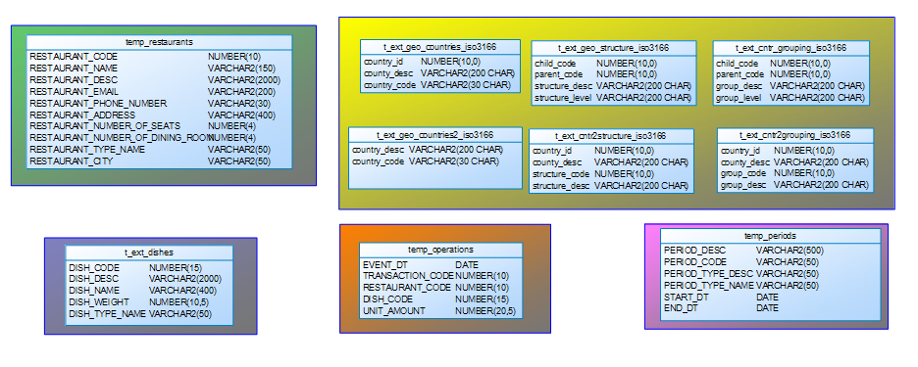

## Stage Solution Scheme (Physical Objects)

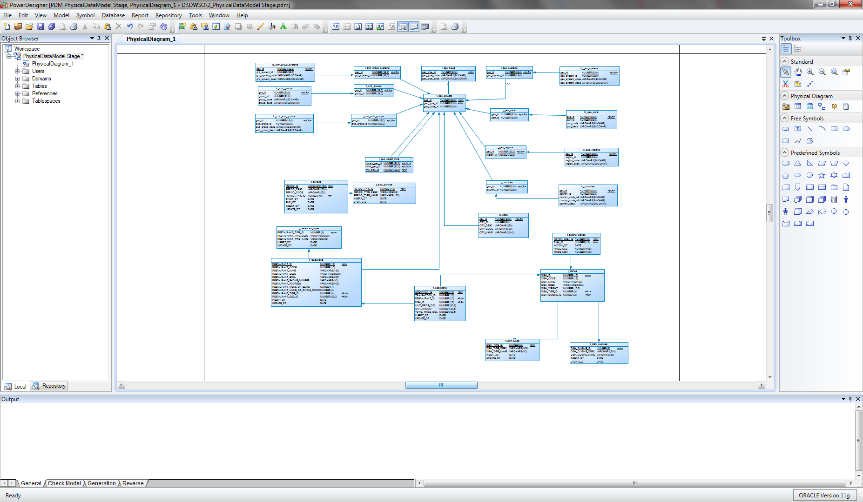

## Star Solution Scheme (Physical Objects)

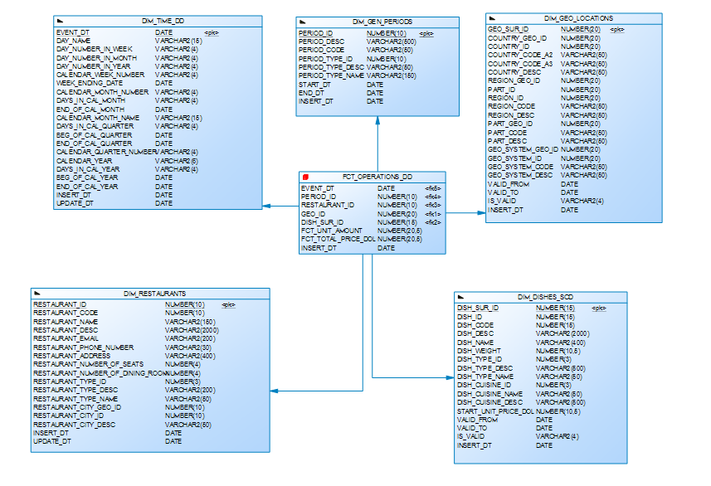

# Result Task 02: Performance comparison

|  |  |  |  |
| --- | --- | --- | --- |
| № | Source Type | Explain Plan - Statistics | Time, Sec. |
| 1 | Advancing Grouping | Cost 1187 | 291 msecs |
| 2 | Model Clause | Cost 1575 | 306 msecs |
| 3 | Star Schema | Cost 310 | 259 msecs |

1. Advancing Grouping

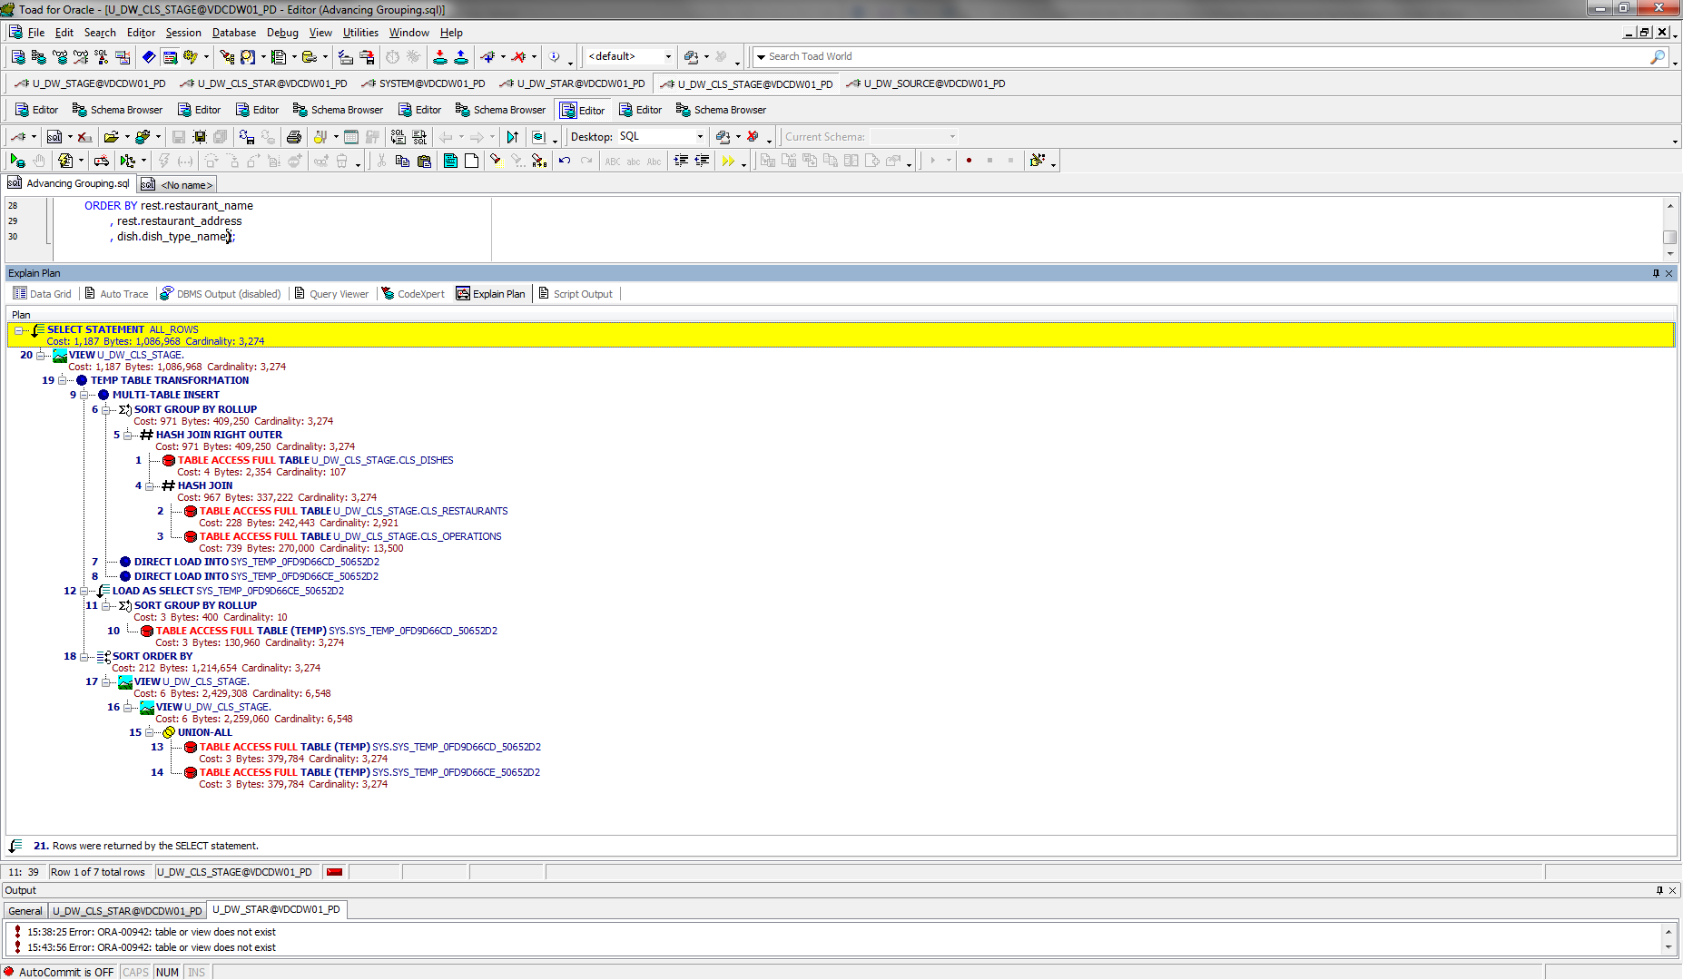

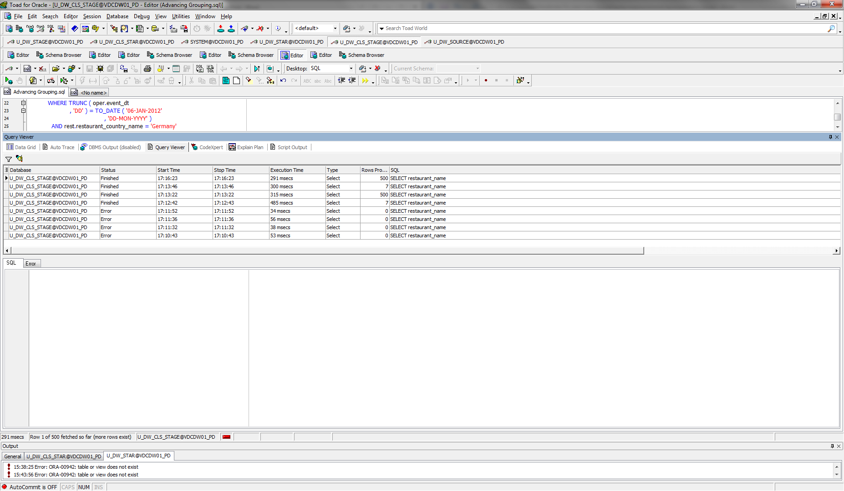

2. Model Clause

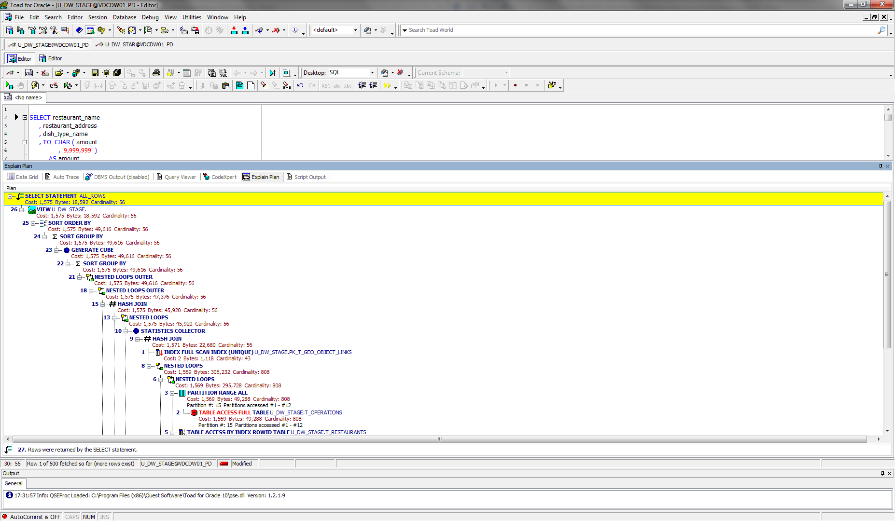

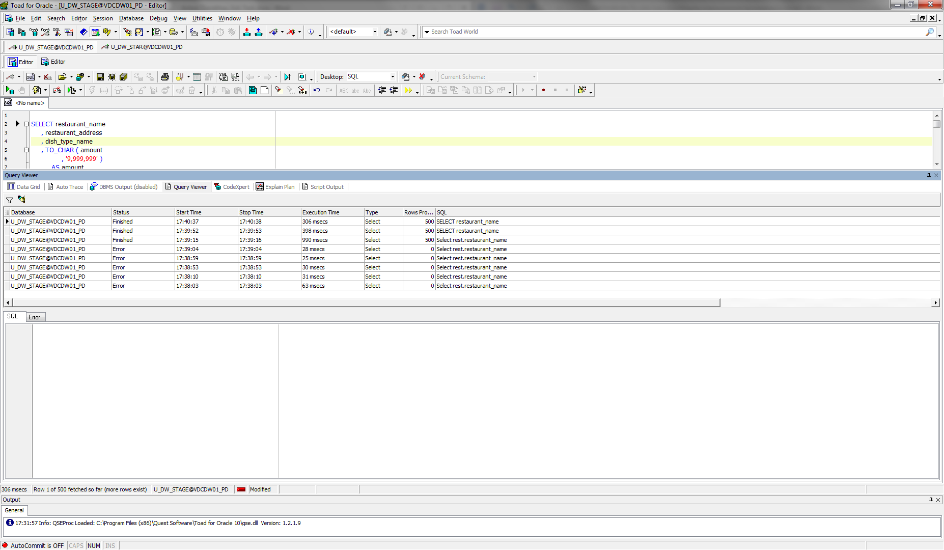

3. Star Schema

